**Objective:** The goal of this week is to practice queries on Aggregate functions like count, max, min, avg, sum and practice queries like nested queries/co- related queries using ANY, ALL, IN, Exists, NOT EXISTS, UNION, INTERSECT, group by and having etc.  
**Task 1: Consider the following database tables and write the solution for the given queries.** Tables: Employee(eid, ename, salary, doj, comm,did) Department(did, departmentname, location)  
 Sample Data in Employees Table:

Q1). Find the employee who earns the maximum salary in their respective department but is not the highest-paid employee in the entire company.

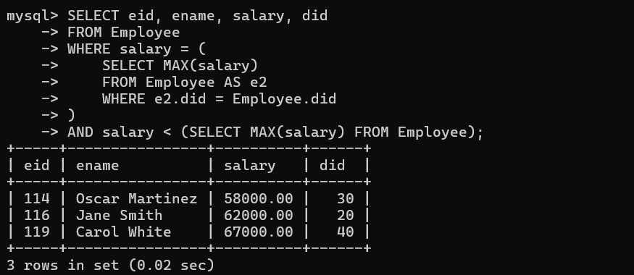

 Q2). Find departments where the total salary expenditure is greater than the average salary expenditure of all departments combined.

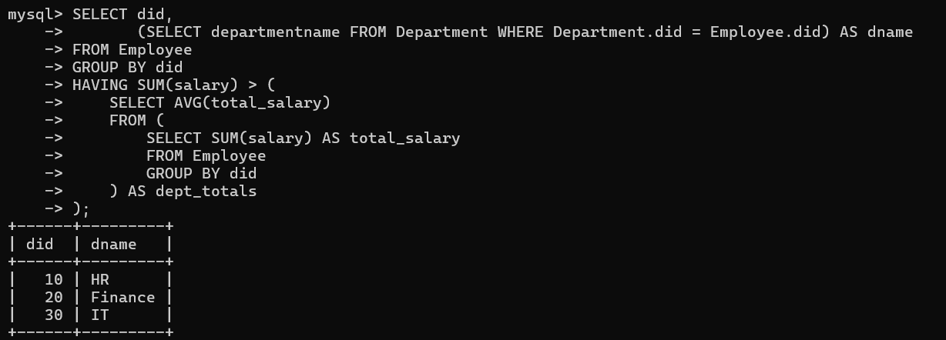

Q3) Find employees who earn more than the average salary of employees in the same department.

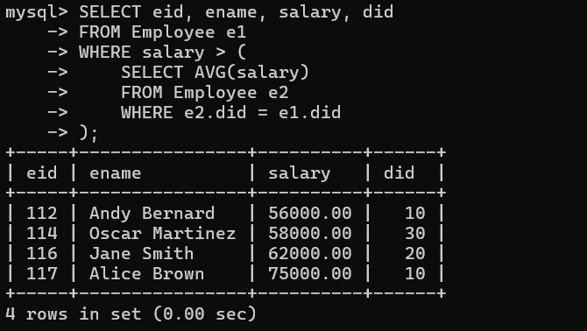  
Q4). List all departments that have exactly the same number of employees as another department.

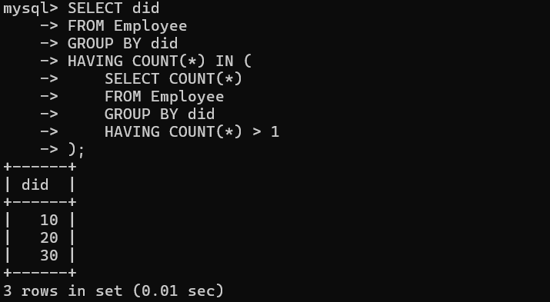

Q5). Find employees who do not share their salary with any other employee.

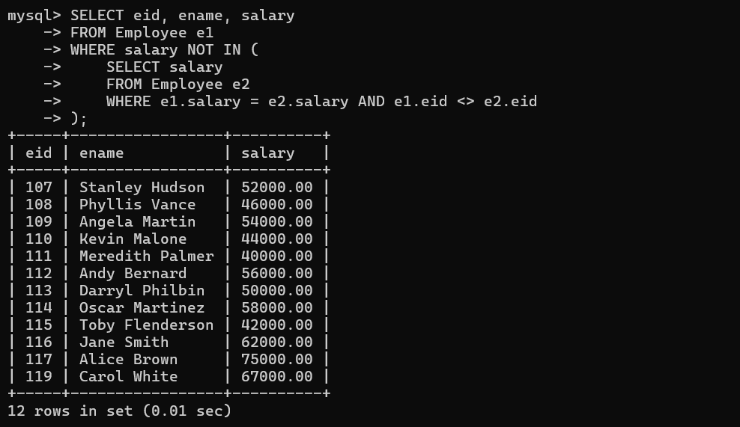  
Q6). Find the departments that have employees earning both the minimum and maximum salary in the company.

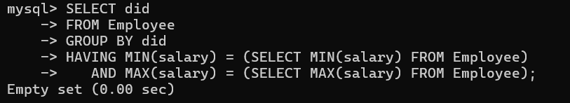

Q7). Find the employee(s) with the highest salary in each department, and then find the average salary of these top earners across all departments.

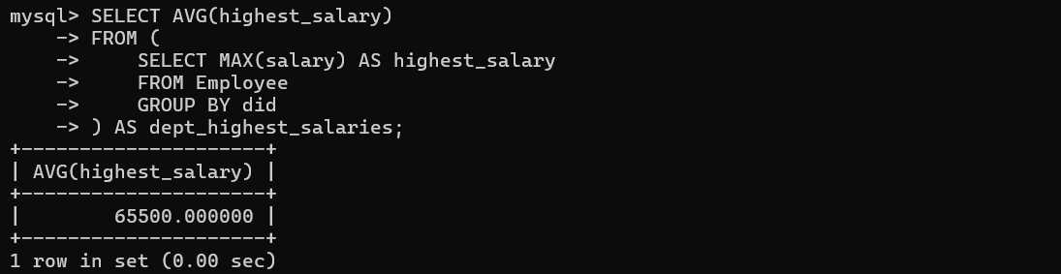  
Q8). List the employees who earn more than the average salary of their department, but less than the overall company average salary.



Q9). Find all employees whose salary is greater than the salary of every employee in department 30, but not greater than the salary of any employee in department 40.

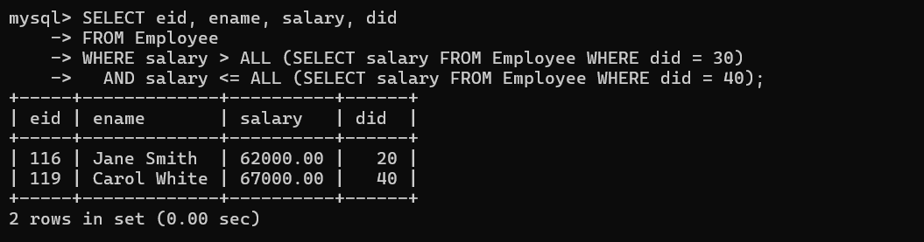  
Q10). List the departments where every employee has a salary greater than the overall average salary of all employees.

  
Q11). Find employees who belong to departments that either have no employees with a salary above 100,000 or have more than 5 employees with a salary above 100,000.

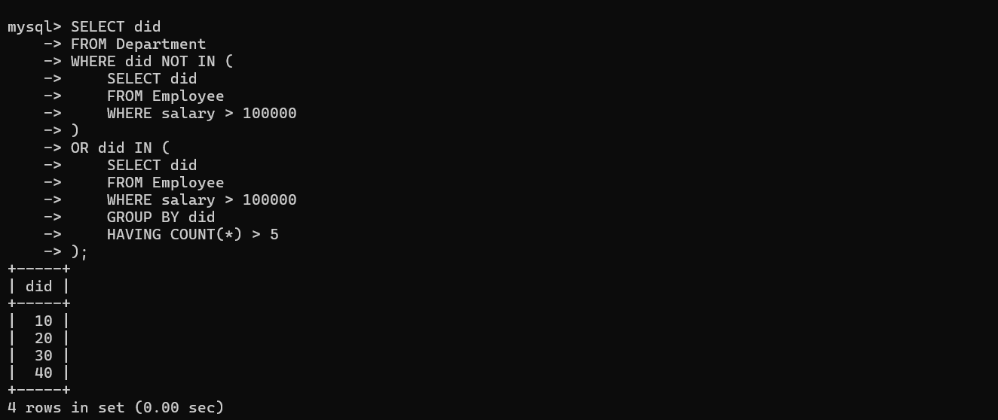

Q12). Find all departments where the total salary expenditure is within 10% of the average total salary expenditure of all departments.

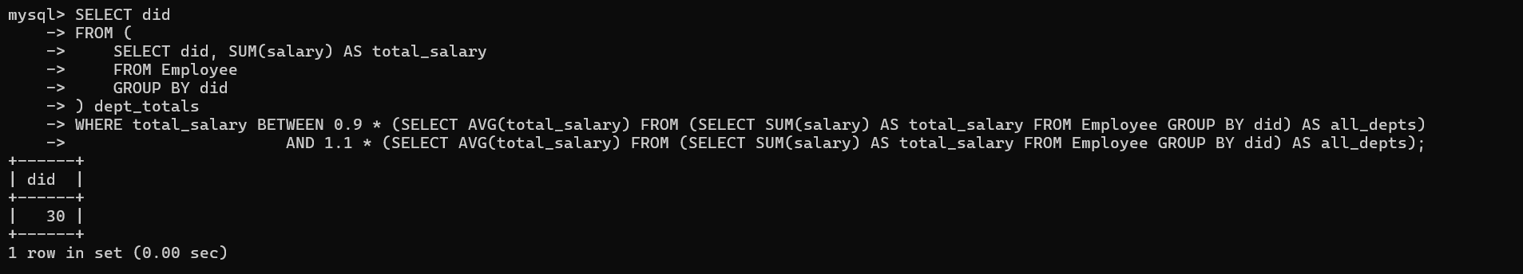

Q13). For each department, find the most common job title and the number of employees with that title.

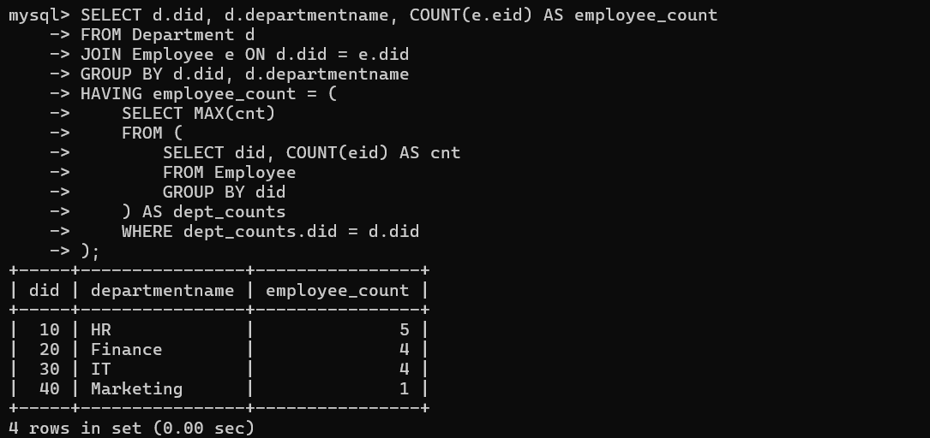  
Q14). Identify departments where the sum of salaries for employees hired before 2020 is greater than the sum of salaries for employees hired after 2020.

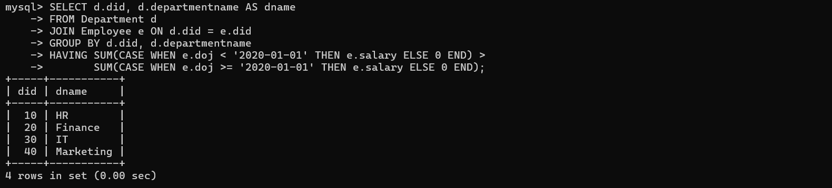

**Task 2: Consider the following database tables and write the solution for the given queries.** Sailors (sid: integer, sname: string, rating: integer, age: real),  
 Boats (bid: integer, bname: string, color: string),  
 Reserves (sid: integer, bid: integer, day: date).

Q15) Find the name and the age of the youngest sailor.



Q16) Find the names of sailors who have reserved boat 103.

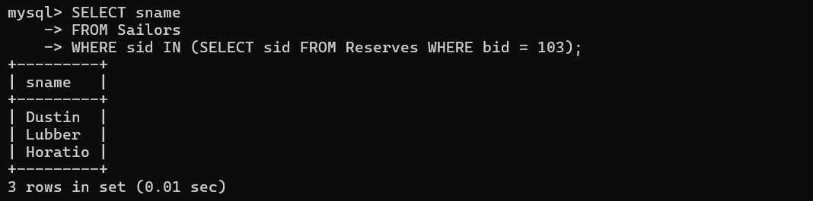  
 Q17) Find the name and the age of the youngest sailor.

  
Q18) Find the names and ratings of sailor whose rating is better than some sailor called Horatio

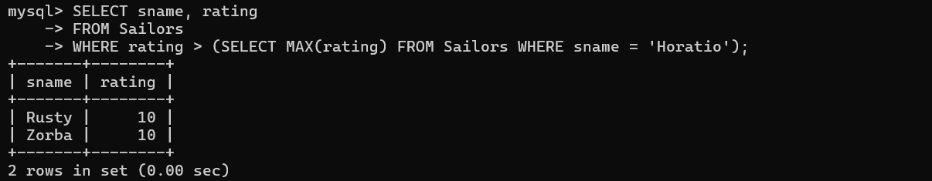  
Q19) Find the names of sailors who have reserved all boats.

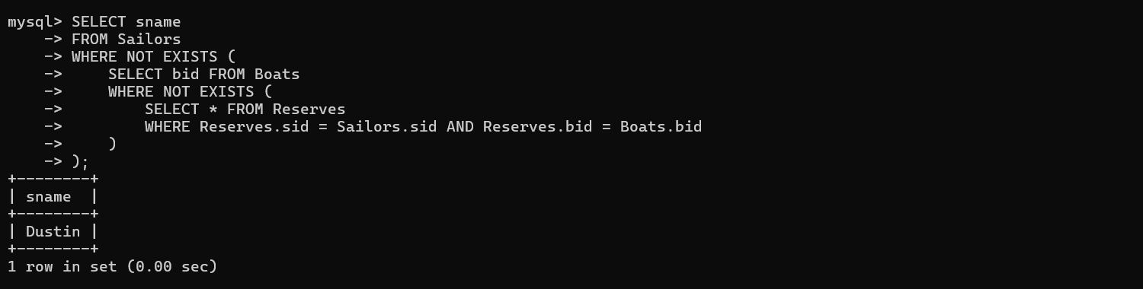  
Q20) Find the ids of sailors who have reserved a red boat or a green boat.

